Date: Thurs Feb 26. Start Time: 11:30. Durration 2 hrs

Thurs manager meeting & work after
- Might need filter (low pass after boost before going to sensors) (look at sensor)
- Boost — switching plane on back
  - Heat vias vs ground vias?
Feedback on critical design revew.
Specific feedback to remove net colors makes it clearer to see what components & traces are on what layer (front /back) . BUT I fount it really difficult to route components, but especially since we need to be done with the PCB & get it reviewed, I removed the colors. Some things that helped was :
- Pressing ‘U’ extends selection of a trace
- ‘D’ drags component and treis to adjust traces, but it doesn’t always owkr
- Tilde button highlights nets

After meeting worked with Lam to get webench to have correct ranges, & correct sizes for components (0805 or 0603 minimum).
Some of the components were custom so we used the filters on digikey to find components with the same or closest specifications.

It was a little frusturating that the design and components kept changing slightly because I had been using the PDF webench report . that LAM posted to the course webpage last week but a lot fo the components were as small as 0201 & they said they had updated the part sizes.
I had tried to put components that had close specs but a larger size, however I’m not sure if different size componetns have different effective resistance/capacitance.

Final boost and buck we bench reports are probably in lams journal
Lam working on updating the schematic, footprints & datasheets of the boost & buck. Also create digikey list of parts by Friday evening
Screenshots of schematics:

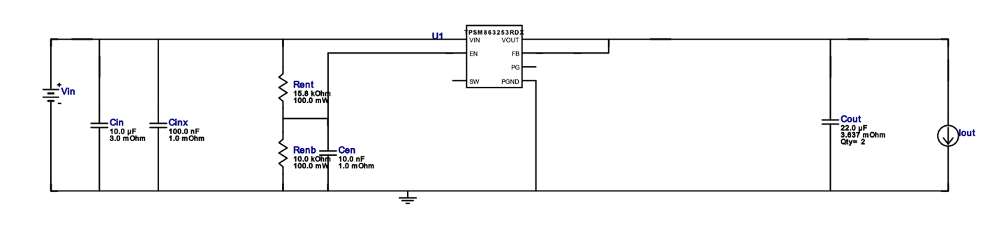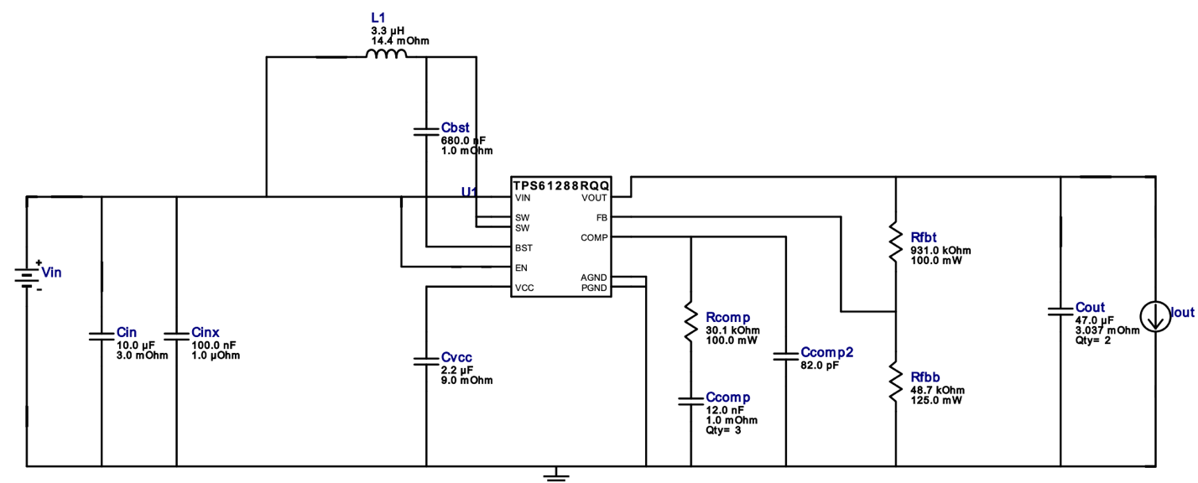

Date: Thurs Feb 26. Start Time: 8:00PM. Durration 1 hrs

Thursday evening spent a few hours re arranging schematic to consolidate space and update components to match digikey list.
Main changes:
- TVS diodes for I2C updated to part that has 2 channels (4 before but only need 2) & TVS diode
- Had to re do some of the layout and routing because compoents change but otherwise no real changes to layout
